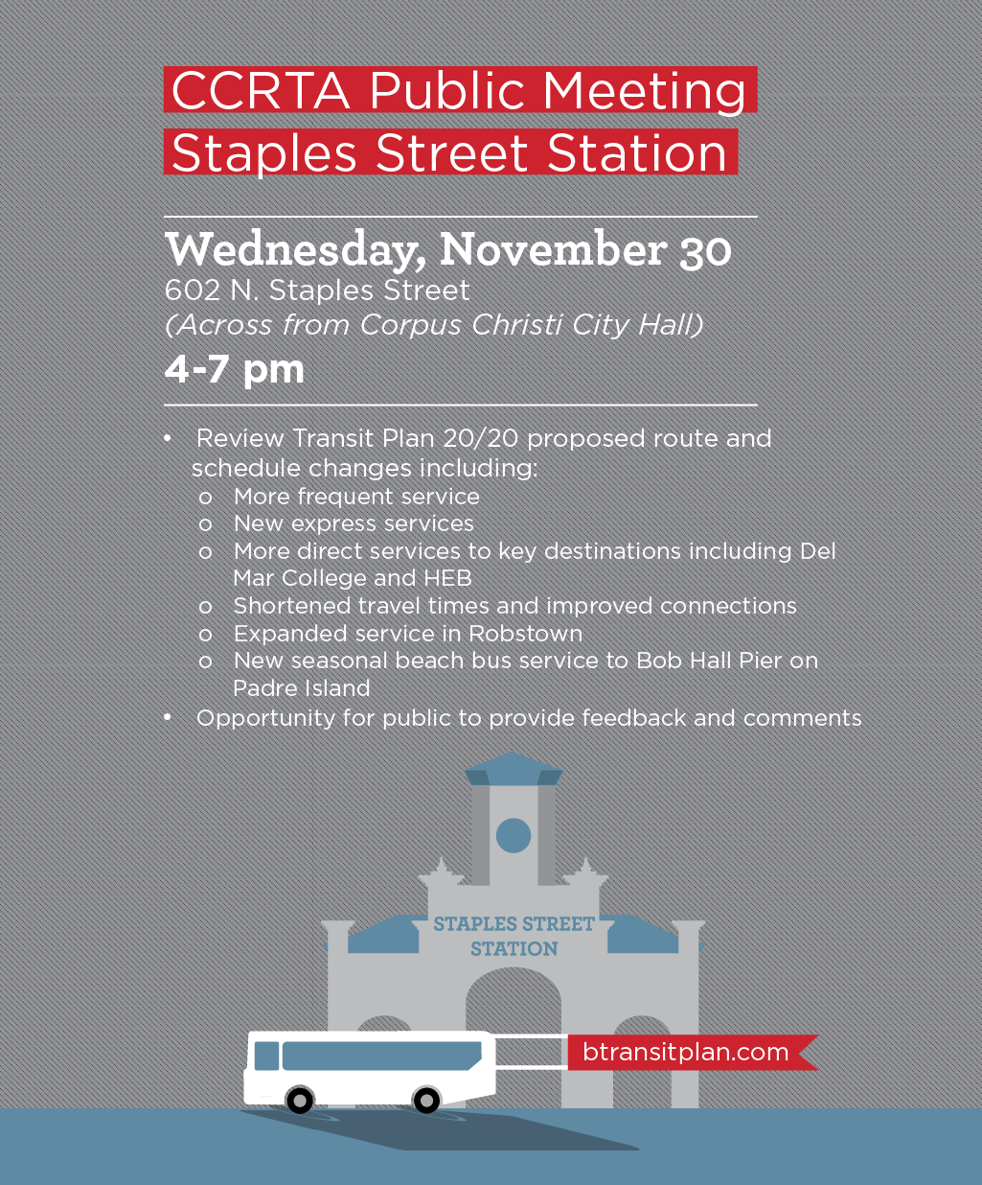
Posting Date: 11/18/2016 Removal Date: 12/01/2016
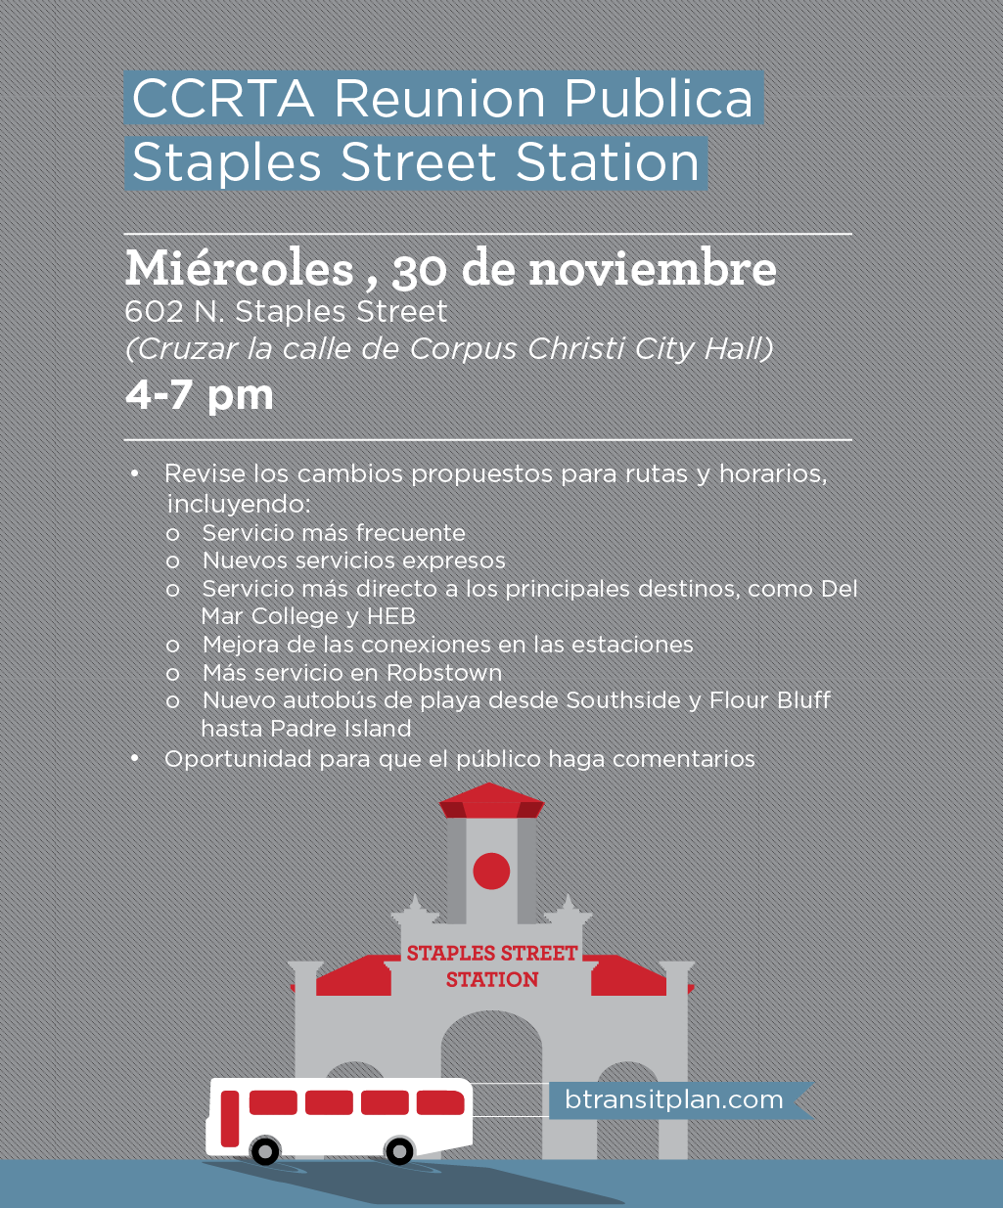
Posting Date: 11/18/2016 Removal Date: 12/01/2016

