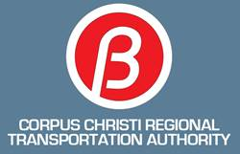

Corpus Christi Regional Transportation Authority (CCRTA)
Staples Street Center

Facilities Use Request
Conference Rooms, Board Room & Green Roof

- Rental Facilities Available for Private and Non Profit Agencies (Exhibit A).

Description | Floor | Seating | Board Panel Seating | Tables | Chairs | Sq. Ft. | Benches (8 ft.) | Podium | Dry Erase Board | Cork Board | Projector/ Screen | TV Monitor
Board Room | 2nd | 126 | 13 |  | 113 | 840 |  | 1 |  |  | 1
Board Room Conference Room | 2nd | 22 |  |  | 22 | 154 |  |  | 1 |  |  | 1
Green Roof / Seating Layout | roof | 80 |  | 2 | 80 | 664 | 5
East Conference Room | 3rd | 9 |  |  | 9 | 80 |  | 1
West Conference Room | 3rd | 9 |  |  | 9 | 80 |  |  | 1

- Room Usage Guideline

The rooms as shown in the above chart (Exhibit A) are equipped with tables and chairs in various layouts that will accommodate a range of people, from 9 to 113. Some are equipped with TV monitors and one has a ceiling mounted projector and an electric pull down screen.

Applicant will adhere to the following guidelines. Please read and initial all.

□ All presentation material MUST be run from the CCRTA computer to be projected on the screen – using a flash drive. If applicant needs to utilized their own laptop, IT will have to be notified. IT requires one week’s notice to examine and train APPLICANT to insure proper installation of the equipment before any laptop is cleared. There is no guarantee that the laptop will be compatible with our projector/sound/screens. Under no circumstances will non-CCRTA approved equipment be hooked up to the projector.
□ Wireless internet access is available via ccrta guest network. No password or login is required.
□ Notify the Building Supervisor* for any computer problems. Only CCRTA personnel have the authority to troubleshoot computer issues. DO NOT attempt this yourself.
□ Contact the Building Supervisor* for any lighting, screen, projector, microphone or sound problems. DO NOT randomly punch buttons on the control panels.
□ Notify the Building Supervisor* if you receive a computer or projector notification–such as “bulb replacement needed” or “clean filter”.
□ Tape, thumbtacks, post-it notes, etc. are not allowed to be placed on the walls.
□ Tables and chairs in the room will not be moved without prior authorization from the Building Supervisor*. This is a layout change – see Section III below.

If food and/or beverages will be served at any time during this reservation, we will adhere to the following guidelines:

□ APPLICANT WILL be responsible for removing all service items and trash to the trash receptacles provided in the rooms.
□ APPLICANT WILL notify the Building Supervisor* immediately if a spill occurs.
□ Food and beverages are allowed in all rooms except the audio visual room in the Boardroom.

*Upon completion of this Facilities Use Request and reservation process his/her contact information identifying the CCRTA Building Supervisor will be forwarded to the event’s contact person as shown on this application.

- Applicant Information
Date Requested:
Time Requested:

Number of Attendees:

Purpose of Event:

❑ Agenda Attached (may be sent later, yet before the event)

Requesting Organization:

Contact Person (attending event):

Phone: Email:

Is your organization a non-profit?  Yes  No

Name and address of individual designated to receive billings:

Name:
Address:

CCRTA/State/Zip:

Phone: Email:

Contact person regarding damage claims:

Name:

Phone: Email:

- Requirements

Is a room layout change or configuration change required?  Yes  No

□ A room layout** change is defined as ANY addition or removal of tables and chairs.
❖ A room configuration change is defined as rearranging the standard layout to a different layout.
❖ Please submit desired layout changes or re-configuration on form provided.

Note: There is an additional fee for any layout or configuration changes.

**Standard layout for rooms shown below. Please use Change Request for anything other than what is shown.
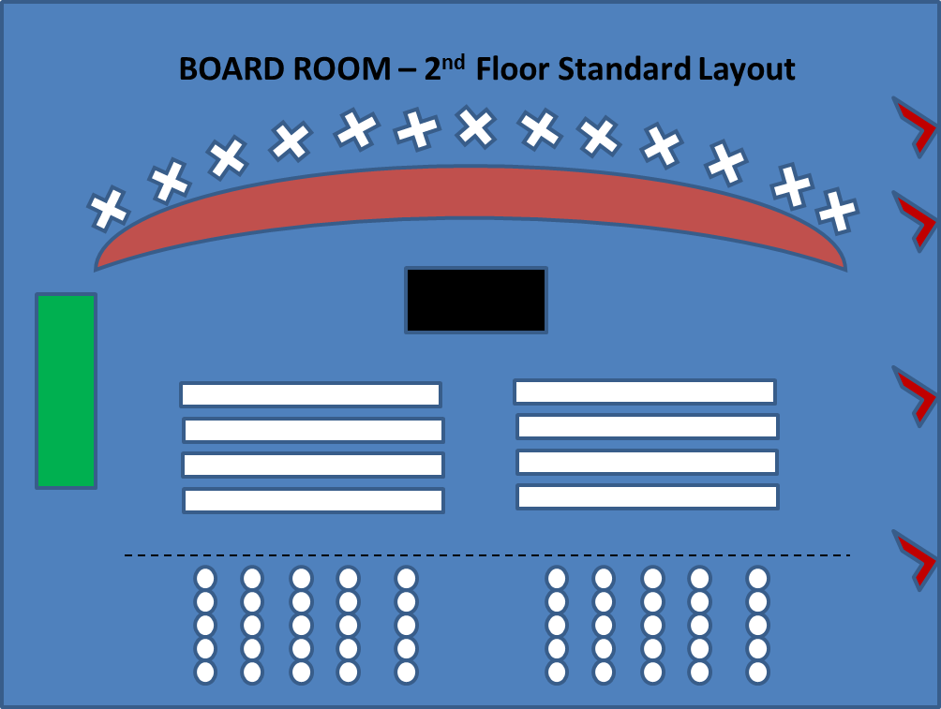
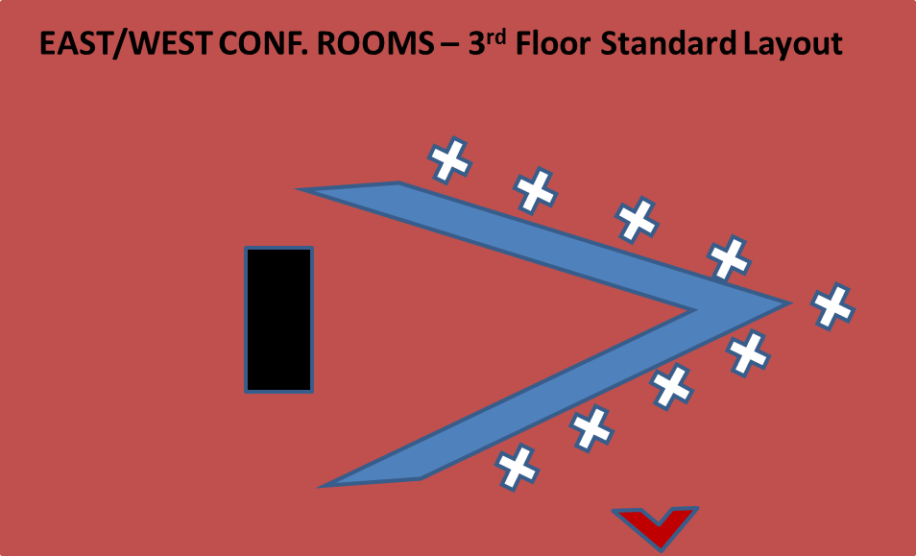

Room Layout/ConfigurationChange Request
In the area below, please draw your desired layout change if any, and fees will be calculated accordingly.

Food and Beverages
Will food and/or beverages be served or allowed in room during this reservation?
(Coffee and water are considered beverages.)  Yes  No

If yes, will this be a catered event or will participants bring their own, and will tables be needed to serve food? If yes, please see room layout change above.

❑ Catered
❑ Breakfast
❑ Lunch
❑ Bring their own from
❑ Dinner
❑ Snacks
❑ Beverages only
(ie. Starbucks coffee, sodas, candy, etc.)

The CCRTA does not provide catering support but has a list of caterers utilized by other businesses in the area. If you would like the information please ask for it.

When food is served please ensure that all necessary health permits are in place whether by the caterer or by others preparing/serving the food.

Will alcohol be served during this reservation?  Yes  No

If yes, then alcohol will be permitted only with liquor liability insurance in the amount of $1,000,000. The policy must name the CCRTA as an “Additional Insured” and be on file with the CCRTA. Confirmation of a liquor caterer/provider (carries $1,000,000 liquor liability insurance) must be completed at least 10 working days in advance of your event.

Alcohol may be sold and consumed only in the building. No one may leave or enter the building with any kind of alcohol, unless it’s the caterers.

Absolutely no one under the age of 21 may consume alcohol on the premises of the CCRTA. Security will enforce this rule.

Will music be provided?
❑ Yes  No

Audio/Visual Equipment
Please check appropriate boxes for audio visual equipment needs:

❑ Computer
❑ Internet
❑ PowerPoint
❑ Other - Please specify:
❑ Podium
❑ Microphones (lapel or hand held)
❑ Projector/Screen
❑ None

Fee/Refund Notes
Fee minimum cost for a time block, regardless if less time is required. Hours noted are “not to exceed”. Additional hours beyond maximum time block hours listed will be charged for an additional time block. Renter must leave a credit card or check on file with CCRTA for additional cost and/or time block overage.

- A minimum of a 30% deposit is required to reserve the facility. Full payment is required 30 days in advance of the event, but payment may be made earlier.
- Cancellation must be received in writing.
- Refund policy:
- 21 days out – full refund
- 14 days out – 50% refund
- 7 days out – 25% refund
- Less than 7 days – Non refundable

The CCRTA shall not be held responsible or liable for any damages caused as a result of the cancellation of the event.

Email this Facilities Use Request and Application to Dena Linnehan, Executive Administrative Assistant to the CEO, at dlinnehan@ccrta.org.

Use of the facilities at the Staples Street Center CANNOT BE CONFIRMED until the rental fee has been paid in full within the 30 day deadline.

Payments may be made in person at the Staples Street Center on the 3rd floor at the CCRTA’s receptionist desk or by mail.

In Person: 602 N. Staples – 3rd floor CCRTA Receptionist

Mail to: Corpus Christi Regional Transportation Authority (CCRTA)
Attn: Dena Linnehan
602 N. Staples
Corpus Christi, TX 78405

Make checks payable to: Corpus Christi Regional Transportation Authority

Cancellations MUST be made in a timely manner
or charges may be incurred.

WE REPRESENT THE ORGANIZATION REQUESTING USE AND UNDERSTAND THAT THE ENTITY FOR WHICH WE ARE THE AUTHORIZED AGENTS IS FINANCIALLY RESPONSIBLE FOR ANY PROPERTY DAMAGE OR PERSONAL INJURY ARISING OUT OF THE RENTAL / USAGE AS REQUESTED ABOVE INTHIS AGREEMENT.

I understand and agree to all guidelines on this form. I take full responsibility for any and all damages that may result from use of the facilities which shall include but is not limited to extra custodial charges and possible repair/replacement costs.

Signature of Authorized Agent(s) Date

Staples Street Center
Fee Schedule - Non Tenants

Business Rates | Hours | Days | Rental Rate
Board Room & Green Roof | 8:00 a.m. - 5:00 p.m. | Monday - Friday | $75/hr.
Board Room & Green Roof | after 5:00 p.m. & weekends | Monday - Sunday | $100/hr.
Conference Rooms | 8:00 a.m. - 5:00 p.m. | Monday - Friday | $50/hr.
Conference Rooms | after 5:00 p.m. & weekends | Monday - Sunday | $75/hr.
Non-Profit Rates | Hours | Days | Rental Rate
Board Room & Green Roof | 8:00 a.m. - 5:00 p.m. | Monday - Friday | $40/hr.
Board Room & Green Roof | after 5:00 p.m. & weekends | Monday - Sunday | $50/hr.
Conference Rooms | 8:00 a.m. - 5:00 p.m. | Monday - Friday | $25/hr.
Conference Rooms | after 5:00 p.m. & weekends | Monday - Sunday | $35/hr.

Building Hours
Monday - Sunday ~ 7:00 a.m. - 12:00 a.m., except holidays.

Additional Fees
$100 One-time fee for major room configuration changes
$25 One-time fee for minor room layout changes
$40/$25 Clean-up fee if food and/or beverages will be served/allowed before 12:00 pm
$60/$50 Clean-up fee if food and/or beverages will be served/allowed after 12:00 pm
$100 Technology usage fees (per 2 hours)
$23 Security Services (per hour) after 5:00 p.m. and weekends
$32 Law Enforcement (per hour) if alcohol is served (per 50 people) (minimum of 4 hours)

Miscellaneous Fees
$20 One-time fee to use the teleconference phone system
$5 Clean-up fee if no food/beverages served (per 4 hours)
$.50 Copies per page request (100 maximum)

**All requests for miscellaneous items must be made at the time of reservation**

ACCEPTED: AUTHORIZED AGENT(S) ACKNOWLEDGED: CCRTA

Signature Authorized Agent(s) Signature Authority

Date Date

PROPOSED STAPLES STREET CENTER
FACILITIES USE RENTAL POLICY
- PURPOSE
This policy is intended to establish equitable rental of the Lakewood CCRTA Hall facilities. The public interest in developing a sense of community is best served by utilizing CCRTA Hall facilities for citizen groups, non-profit and private organizations.

- DEFINITIONS
Applicant: Must be at least 18 years of age. Refers to individuals or groups reserving a facility and completing and signing a facility rental application.

CCRTA-related groups: Activities including programs and meetings sponsored or implemented by the CCRTA departments or divisions, including but not limited to, CCRTA committees and boards, CCRTA staff meetings, and other CCRTA sponsored meetings.

CCRTA Building Hours: Monday –Sunday 7:00 a.m. – 12:00 a.m.

CCRTA Operating Hours: Monday – Friday 8:00 a.m. – 5:00 p.m., except holidays.

CCRTA staff attendant hourly rate fee: Hourly rate of current salary level of CCRTA personnel to operate CCRTA-owned equipment, provide for security and/or provide for additional cleaning and/or repairs.

Clean up: The activity involving sweeping (if necessary), cleaning table tops, putting away tables and chairs, removing decorations and disposing of garbage. Applicant will be responsible for putting away furniture and leaving facility/building and restrooms in the condition received. Only CCRTA custodians shall use chemicals.

Cleaning Fee: The fee charged for cleaning a CCRTA facility as designated in the Resolution established for fees.

Set-up: This activity includes arranging tables, chairs, equipment and decorations and is the responsibility of the applicant.

Security: The CCRTA will provide security personnel at the CCRTA’s discretion. If the use of CCRTA Police, security or private security guard is needed, the expense will be the responsibility of the applicant.

- POLICY
- All use is to be in accordance with the following policies.

- The CCRTA facilities are available to outside entities/others for their use and enjoyment, and are also available to non-residents. The CCRTA does not discriminate on the basis of race, creed, color, national origin, religion, gender, marital status, age, sexual orientation, and political affiliation, sensory, mental or physical disability. Any persons or group using the facilities shall not exclude any persons from their activities at Staples Street Center on the basis of this non-discriminatory policy.

- Permission to use the facilities does not constitute an endorsement of a group’s philosophies, policies or beliefs.

- The CCRTA’s Chief Executive Officer (CEO) or the CEO’s designated representative shall make any necessary interpretation of any CCRTA’s Policy.

- The CCRTA’s Board of Director’s establishes all fees related to CCRTA facilities usage by Resolution. The CCRTA’s CEO has the authority to amend the categories and usage time. The CEO reserves the right to make any changes to these policies at any time.

- Violation of these policies may result in the immediate termination of the rental or use agreement.

- PROCEDURES
- Any person or group wanting to use CCRTA facilities shall make application for facility rental on forms provided by the CCRTA. Additional information may be required. Applications are available from the CCRTA, Staples Street Center on the third floor, and at the Customer Service counter on the first floor at. Completed applications and applicable fees must be submitted to the Dena Linnehan, Executive Assistant to the CEO.

- All scheduling of citizen groups use of CCRTA conference rooms located at
602 N. Staples will be done through the Executive Assistant to the CEO.

- Reservations for private use be made a maximum of six (6) months prior to the desired date, and must be made by written application. No formal reservations will be accepted by phone.

- Use of the CCRTA Hall facilities and assessment of fees will be approved in writing by the CCRTA Manager or designated representative.

- Rental application may be revoked for violation of policies. Rental application shall not be assigned or sublet.

- GENERAL REGULATIONS
Reservations
- Use of the facility will be limited to persons or groups who are legally willing and financially capable of accepting responsibility for the meeting or activity, the structure and contents of the activity. The CCRTA reserves the right to require forms, liability insurance, deposits, applications and documents as may be necessary to protect the investment in its facilities. Meetings or activities shall be conducted in an orderly manner. The user (applicant) shall be financially responsible for personal injuries or property damages arising from the meetings or activities.

- Reservations for use may be made up to six (6) months in advance of the activity on a first come basis. However, to encourage use of the facilities by a wide range of organizations and agencies, the CCRTA expressly reserves the right to refuse to rent the facilities at any time. CCRTA-related groups have first priority in scheduling the use of CCRTA owned facilities. No group, except for CCRTA-related groups, shall be allowed to monopolize the use of the facilities.

- A reservation will be confirmed as booked upon receipt, by the CCRTA, of the Rental Application and full payment of the rental fee/deposit. The applicant shall not advertise its use of any CCRTA facility until the reservation is confirmed.

- The time period reserved includes the time needed for set up, decorating, deliveries, preparation and clean-up.

- Reservations for consecutive day activities will be based on availability of space.

- Unless written approval has been granted, no group using CCRTA facilities will be allowed to use the CCRTA logo or imply in any way that the CCRTA is a sponsor/co-sponsor of the event or activity.

- Applicant shall provide the CCRTA with copies of all required permits and insurance coverage no less than fifteen (15) days in advance of the rental date(s). Failure to obtain required permits and insurance is grounds for forfeiture of the rental fee and use of the facility.

- Ongoing, regularly scheduled bookings will be considered but will not be allowed to monopolize the time available for rental use.

Hours of Operation
- CCRTA Staples Street Center’s facilities are available for training sessions or meeting type events during CCRTA operating hours Monday through Friday 8:00 a.m. to 5:00 p.m., except holidays.

- CCRTA Staples Street Center facilities are available for users during CCRTA’s non-operating hours Monday through Sunday 5:00 p.m. – 12:00 a.m. except holidays.

- Activities must cease by 12:00 a.m.

Fee Payment
The payment must be made no later than 30 days before the event in order for the rental application to be confirmed. If payment is not made in full by the 30-day deadline, then the space will be released and become available for others to lease.

Facilities and Equipment
- Facilities and equipment shall be left in the condition that was present prior to the rental.

- Users of the facilities shall be responsible for provisions of materials, supplies and decorations to be used in conjunction with the use of the facilities.

- User/Applicant is responsible for: (1) supervision and control of group or individuals to prevent injury and ensure safety before, during and after use of CCRTA Hall facilities; (2) payment of fees and charges; and (3) damage or loss to equipment, property or grounds which may be incurred as a result of the scheduled activity.

- Any activity that utilizes CCRTA-owned equipment including but not limited to, the public announcement system with speakers or any microphones, TV/VCR, and overhead projector, will require CCRTA staff (at the two-hour rate established by the CCRTA) to assist with the operation of the equipment.

- The CCRTA is not responsible to store articles or supplies. The CCRTA is not responsible for loss or theft of articles during the rental of CCRTA facilities and/or left in the facility.

- Users of the facilities shall observe and comply with all applicable CCRTA, State, and Federal laws, rules and regulations.

Damage
- Users of CCRTA facilities are financially responsible for any damage to property or loss of property. A fee equal to the total replacement cost will be charged.

- The applicants shall be required to pay the full cost of breakage, damage or loss to CCRTA facilities and/or equipment, regardless of amount. Up to a 15 percent administrative fee may be added to the actual expenses and an hourly fee will be charged for repairs or additional cleaning that is required as a result of an event. Failure to remit the required payment shall bar the applicant from any further use of the facility. Any amount unpaid for more than 60 days will be turned over to a collection agency.

Liability
The applicant agrees to indemnify and hold the CCRTA, its Board members, officers, employees, agents, and volunteers harmless from any and all claims, demands losses, actions and liabilities, (including costs and all attorney fees), to or by any and all persons or entities, including, without limitation, their respective agents, licensees, or representatives, arising from, resulting from or connected with this Agreement to the

extent caused by negligent acts, errors or omissions of the applicant, or by the Applicant’s breach of this agreement.

Insurance
- Certificate of Insurance may be required before the facility may be rented. The Certificate must provide insurance coverage of at least $1,000,000 for bodily/property damage and it must name the CCRTA as an additional insured. A Certificate of Insurance can be obtained from your insurance agent.

Staffing
The CCRTA shall require a CCRTA staff member to be in attendance at all activities that require the use of CCRTA-owned equipment, including but not limited to, audio visual equipment, at CCRTA Staples Street Center. Cost for CCRTA staff will be assessed at the time of application to be part of the user fee. When an activity warrants the presence of one or more certified security personnel, the cost of this service shall be obtained and paid for by the applicant sponsoring the activity.

Minors
An application for use of the facility must be made by the adults who will be responsible for and in attendance at the activity.

Groups composed of minors shall be supervised by adults (21 years of age or older) at all times while using CCRTA facilities.

Decoration
Any decorating or other alterations to the existing facilities will be subject to prior approval by the CCRTA CEO or designee. No objects are to be suspended or attached to ceilings, walls, or windows without prior approval. NO confetti or glitter.

As a general rule, use of any open flame is not permissible in any public building. If the use of an open flame is desired, prior clearance must be granted in writing from the CCRTA Manager or designee.

Floors
No objects are to be attached to floors by any method, and no materials are to be applied to floors without prior approval.

Smoking
No smoking of any kind is permitted inside CCRTA Hall facilities.

Cleanup
Facilities and equipment both inside and outside the building shall be left in the same condition as found prior to the activity. The cost of any additional cleaning or repairs required as a result of the event will be added to the user’s bill.

- FOOD AND BEVERAGE REGULATIONS
Alcohol
Use of alcoholic beverages on CCRTA Staples Street Center property is allowed.

Food
Minimum food preparation areas are available. Kitchen facilities should be toured in advance of holding an event. Proper Health Department licenses/permits will be required for events serving hot food prepared on or off-site.

- ACTIVITIES
Music
The renter shall respect the rights and privacy of the surrounding neighborhood. Amplified music shall be permitted, but must be kept at a reasonable level and all city noise statutes must be respected. If, in the opinion of the CCRTA staff/security the noise level has exceeded a reasonable level, the renter will be asked to lower the noise level. Upon the third request to lower the noise level, the renter may be asked to terminate the function, clean the facility of what they brought in, and vacate the premises.

