# 

# 

**Corpus Christi Regional Transportation Agency**

**2018 CALL FOR PROJECTS AND FUNDING APPLICATION INSTRUCTIONS**

FOR FTA’s ENHANCED MOBILITY OF SENIORS AND INDIVIDUALS WITH DISABILITIES (SECTION 5310)

CORPUS CHRISTI URBANIZED AREA



# Introduction

This application package is for the 2018 Call for Projects for the Enhanced Mobility of Seniors and Individuals with Disabilities Funding Program (Section 5310). This 5310 funding application package includes information on funding availability, project eligibility, the application timeline, the application process and the project evaluation criteria.

The Corpus Christi Regional Transportation Authority (CCRTA) is the designated recipient for the 5310 funding in the Corpus Christi Urbanized Areas. As the designated recipient, CCRTA is responsible for developing a 5310 Program Management Plan (Plan) and administering a Call-for-Projects for the available funding. Interested and eligible applicants should review the Plan and the application package before applying.

**Eligible Applicants**

Under the federal guidelines, the following entities are eligible to apply for §5310 funding:

* Private nonprofit organization
* State or Local governmental authority
* Public and private operators of transportation services
* Tribal governments

To be eligible for funding from the §5310 programs, proposed projects must be located or either have an origin or a destination within the Corpus Christi urbanized area.

**Funding Availability**

Funding available is listed in Table 1 below.

|  |  |
| --- | --- |
| Fiscal Year | Funding Amount |
| 2016 | $300,650 |
| 2017 | $294,434 |

# Program Purpose

The goal of the Section 5310 program is to improve mobility for seniors and individuals with disabilities throughout the country by removing barriers to transportation services and expanding the transportation mobility options available. Toward this goal, FTA provides financial assistance for transportation services planned, designed, and carried out to meet the special transportation needs of seniors and individuals with disabilities in all areas—large urbanized, small urbanized, and rural. The program requires coordination with other federally assisted programs and services in order to make the most efficient use of federal resources. CCRTA is the public transportation provider in the Corpus Christi Urbanized Area and is the Designated Recipient for §5310 funds allocated within the Corpus Christi Urbanized area.

# Project Eligibility

Section 5310 funds are available for capital and operating expenses to support the provision of transportation services to meet the specific needs of elderly persons and persons with disabilities. All projects must either be situated in the Corpus Christi Urbanized Area or may also originate in a rural area but must have the final destination be situated in an urbanized area within the region to qualify for Section 5310 Urbanized Area funds. See figure 1 on Page 9 for a map of the Corpus Christi Urbanized Area.

At least 55 percent of any rural, small or large urbanized area’s annual apportionment must be utilized for public transportation capital projects that are planned, designed, and carried out to meet the specific needs of elderly persons and persons with disabilities. It is not sufficient that elderly persons and persons with disabilities are merely included (or assumed to be included) among the people who will benefit from the project.

Eligible projects for the required 55 percent of capital projects include the capital cost of contracting for the provision of transit services for elderly persons and persons with disabilities and other specialized shared-ride transportation services. The acquisition of Americans with Disabilities Act (ADA) complementary paratransit service are eligible capital expenses that may also qualify as public transportation capital projects planned, designed, and carried out to meet the specific needs of elderly persons and persons with disabilities when public transportation is insufficient, unavailable, or appropriate, provided the projects are carried out by eligible sub-recipients and these projects are included in the area’s South Texas Planning Region Public Transportation Coordination Plan. <https://www.ccrta.org/wp-content/uploads/2017/03/Final-CB-Regionally-Coordinated-Plan-2017-20211.pdf>

In addition to the above required capital projects, up to 45 percent of an area’s apportionment may be utilized for additional public transportation projects that:

1. Exceed the ADA minimum requirements;
2. Improve access to fixed-route service and decrease reliance by persons with disabilities on ADA-complementary paratransit service; or
3. Provide alternatives to public transportation that assist elderly persons and persons with disabilities with transportation.

The remaining 45 percent may be used for public transportation projects that exceed the requirements of ADA, public transportation projects that improve access to fixed-route services and decrease reliance by individuals with disabilities on complementary paratransit and alternatives to public transportation that assist seniors and individuals with disabilities. These types of projects were allowed under the old New Freedom program. It is important to remember that under MAP-21, the Section 5317 New Freedom program was consolidated into the 5310 program. One new element is that the Section 5310 Enhanced Mobility program permits the acquisition of public transportation services as a capital expense.

For more information on FTA Section 5310 Enhanced Mobility regulations and requirements follow the following link: <https://www.transit.dot.gov/funding/grants/enhanced-mobility-seniors-individuals-disabilities-section-5310>

# Traditional Capital Expenses

Funds for the Section 5310 program are available for capital expenses to support public transportation capital projects planned, designed, and carried out to meet the special needs of elderly persons and persons with disabilities when public transportation is insufficient, unavailable, or inappropriate. Examples of capital expenses that meet the 55 percent requirement, which must be carried out by an eligible recipient or sub-recipient, include, but are not limited to:

a. Related activities for Section 5310-funded vehicles

(1) Vehicle rehabilitation or overhaul;

(2) Preventive maintenance;

(3) Radios and communication equipment; and

(4) Vehicle wheelchair lifts, ramps, and securement devices.

b. Passenger facilities related to Section 5310-funded vehicles

(1) Purchase and installation of benches, shelters, and other passenger amenities.

c. Support facilities and equipment for Section 5310-funded vehicles

(1) Extended warranties that do not exceed the industry standard;

(2) Computer hardware and software;

(3) Transit-related intelligent transportation systems (ITS);

(4) Dispatch systems; and

(5) Fare collection systems.

d. Acquisition of transportation services under a contract, lease, or other arrangement. This may include acquisition of ADA-complementary paratransit services when provided by an eligible recipient or sub-recipient as defined above under the Introduction sub-heading. Both capital and operating costs associated with contracted service are eligible capital expenses. User-side subsidies are considered one form of eligible arrangement. Funds may be requested for contracted services covering a time period of more than one year. The capital eligibility of acquisition of services as authorized in 49 U.S.C. 5310(b)(4) is limited to the Section 5310 program;

d. Support for mobility management and coordination programs among public transportation providers and other human service agencies providing transportation. Mobility management is an eligible capital cost. Mobility management techniques may enhance transportation access for populations beyond those served by one agency or organization within a community. For example, a nonprofit agency could receive Section 5310 funding to support the administrative costs of sharing services it provides to its own clientele with other seniors and/or individuals with disabilities and coordinate usage of vehicles with other nonprofits, but not the operating costs of service. Mobility management is intended to build coordination among existing public transportation providers and other transportation service providers with the result of expanding the availability of service. Mobility management activities may include:

(1) The promotion, enhancement, and facilitation of access to transportation services,

including the integration and coordination of services for individuals with disabilities,

seniors, and low-income individuals;

(2) Support for short-term management activities to plan and implement coordinated

services;

(3) The support of state and local coordination policy bodies and councils;

(4) The operation of transportation brokerages to coordinate providers, funding agencies,

and passengers;

(5) The provision of coordination services, including employer-oriented transportation

management organizations’ and human service organizations’ customer-oriented

travel navigator systems and neighborhood travel coordination activities such as

coordinating individualized travel training and trip planning activities for customers;

(6) The development and operation of one-stop transportation traveler call centers to

coordinate transportation information on all travel modes and to manage eligibility

requirements and arrangements for customers among supporting programs; and

(7) Operational planning for the acquisition of intelligent transportation technologies to

help plan and operate coordinated systems inclusive of geographic information

systems (GIS) mapping, global positioning system technology, coordinated vehicle

scheduling, dispatching and monitoring technologies, as well as technologies to track

costs and billing in a coordinated system, and single smart customer payment

systems. (Acquisition of technology is also eligible as a standalone capital expense).

g. Capital activities (e.g. acquisition of services, etc.) to support ADA-complementary paratransit service may qualify toward the 55 percent requirement, so long as the service is provided by an eligible recipient/sub-recipient.

Section 5310(b) provides that of the amounts apportioned to states and designated recipients, not less than 55 percent shall be available for traditional Section 5310 projects –those public transportation capital projects planned, designed, and carried out to meet the specific needs of elderly persons and persons with disabilities when public transportation is insufficient, unavailable, or inappropriate. Notably, this 55 percent is a floor, not a ceiling-recipients may use more than 55 percent of their apportionment for the types of project listed above. For example, mobility management and ITS projects may be eligible under both categories; the difference to note, in order for the project to qualify toward the 55 percent requirement, is that the project must meet the definition of a capital project, be specifically geared toward the target population, and carried out by an eligible sub-recipient, which is limited for this category of projects. The list of eligible activities is intended to be illustrative, not exhaustive. FTA encourages recipients to develop innovative solutions to meet the needs of elderly persons and persons with disabilities in their communities and discuss proposed projects with FTA regional staff to confirm eligibility.

# Other Eligible Capital and Operating Expenses

Up to 44 percent of 5310 funds may be used for operating expenses that provide transportation services that exceed the requirements of the ADA or improved access to fixed route services and decrease reliance by persons with disabilities on ADA complementary transit service.

1. Public transportation projects (capital only) planned, designed, and carried out to meet the special needs of elderly persons and persons with disabilities when public transportation is insufficient, inappropriate, or unavailable.
2. Public transportation projects (capital and operating) that exceed the requirements of ADA;
3. Public transportation projects (capital and operating) that improve access to fixed route service and decrease reliance by persons with disabilities on ADA-complementary paratransit service; or
4. Alternative to public transportation (capital and operating) that assist elderly persons and persons with disabilities with transportation.

# Projects that Exceed the Requirements of the ADA (previously 5317 Program)

The following activities are examples of eligible projects meeting the definition of public transportation service that is beyond the ADA or former Section 5317 projects.

1. Enhancing paratransit beyond minimum requirements of the ADA. ADA-complementary paratransit services can be eligible under the Section 5310 program in several ways:
2. Expansion of paratransit service parameters beyond the three-fourths mile required by the ADA;
3. Expansion of current hours of operation of ADA paratransit services that are beyond those provided on the fixed-route services;
4. The incremental cost of providing same-day service;
5. The incremental cost (if any) of making door-to-door service available to all eligible ADA paratransit riders, but not on a case-by-case basis for individual riders in an otherwise curb-to-curb system;
6. Enhancement of the level of service by providing escorts or assisting riders through the door of their destination; and
7. Installation of additional securement locations in public buses beyond what is required by the ADA.
8. Feeder services. Accessible “feeder” service (transit service that provides access) to commuter rail, commuter bus, intercity rail, and intercity bus stations, for which complementary paratransit service is not required under the ADA.

# Public Transportation Projects that Improve Accessibility

The following activities are examples of eligible projects that improve accessibility to the fixed-route system.

1. Making accessibility improvements to transit and intermodal stations not designated as key stations. Improvements for accessibility at existing transportation facilities that are not designated as key stations established under 49 CFR 37.47, 37.51, or 37.53, and that are not required under 49 CFR 37.43 as part of an alteration or renovation to an existing station, so long as the projects are clearly intended to remove barriers that would otherwise have remained. Section 5310 funds are eligible to be used for accessibility enhancements that remove barriers to individuals with disabilities so they may access greater portions of public transportation systems, such as fixed-route bus service, commuter rail, light rail, and rapid rail. This may include:
2. Building an accessible path to a bus stop that is currently inaccessible, including curb cuts, sidewalks, accessible pedestrian signals, or other required under the ADA;
3. Adding an elevator or ramps, detectable warnings, or other accessibility improvements to a non-key station that are not otherwise required under the ADA;
4. Improving signage or wayfinding technology; or
5. Implementation of other technology improvements that enhance accessibility for people with disabilities including ITS.
6. Travel Training. Training programs for individual users on awareness. Knowledge, and skills of public and alternative transportation options available in their communities. This includes travel instruction and travel training services.

# Public Transportation Projects that Assist Elderly persons and Persons with disabilities with Transportation

The following activities are examples of projects that are eligible public transportation alternatives.

1. Supporting the administration and expenses related to voucher programs for transportation services offered by human service providers. This activity is intended to support and supplement existing transportation services by expanding the number of providers available or the number of passengers receiving transportation services. Vouchers can be used as an administrative mechanism for payment of alternative transportation services to supplement available public transportation. The Section 5310 program can provide vouchers to seniors and individuals with disabilities to purchase rides, including (a) mileage reimbursement as part of a volunteer driver program; (b) a taxi trip; or (c) trips provided by a human service agency. Providers of transportation can then submit the voucher for reimbursement to the recipient for payment based on predetermined rates or contractual arrangements. Transit passes or vouchers for use on existing fixed-route or ADA complementary paratransit service are not eligible. Vouchers are an operation expense which requires a 50/50 (federal/local) match.
2. Supporting volunteer driver and aide programs. Volunteer driver programs are eligible and include support for costs associated with the administration, management of driver recruitment, safety background checks, scheduling, coordination with passengers, other related support functions, mileage reimbursement, and insurance associated with volunteer driver programs. The costs of enhancements to increase capacity of volunteer driver programs are also eligible. FTA encourages communities to offer consideration for utilizing all available funding resources as an integrated part of the design and delivery of any volunteer driver/aide program.

# Cost Sharing/Match Requirement:

5310 funds are eligible to support up to 80% of the cost of capital projects and up to 50% of the net operating costs. Some potential capital match exceptions are noted in the FTA guidance (FTA C 9070.1G) and the Corpus Christi Regional Transportation Authority 5310 Program Management Plan.

The local share may be provided from an undistributed cash surplus, a replacement or depreciation cash fund, reserve, and a service agreement with a state or local service agency, private social service organization or new capital. Some examples of these sources of local match include:

* State or local appropriations
* Dedicated tax revenues
* Private donations
* Revenue from service contracts
* Transportation Development Credits (TDCs)
* Net income generated from advertising and concessions

Non-cash share:

* Donations
* Volunteered services
* In-kind contributions are accepted with respect to the following:
* Eligible to be counted toward local match as long as the value of each is documented and supported;
* Represents a capital cost which would otherwise be eligible under the program; and
* Included in the net project cost in the project budget

The source(s) of local funding must be identified in the initial 5310 grant application. The use and certification of Transportation Development Credits (TDCs) is the sole responsibility of the sub-recipient in most cases. TDC certification documentation must be provided to CCRTA and CCRTA must include the documentation in the FTA TrAMS grant application. CCRTA will assist sub-recipients in obtaining the TDC Certification documentation from the Texas Department of Transportation (TxDOT) and act in behalf of the sub-recipient when TDCs are requested.

# Eligible Expenses and Reimbursement

Qualifying expenditures are reimbursed to the sub-recipient by the FTA through the CCRTA, when submitted with appropriate accompanying documentation. The application for reimbursement must be accompanied by detailed back-up documentation for all eligible expenses. At a minimum, the documentation shall include, but is not limited to a listing of all invoiced costs with vendors and payment dates, and copies of paid invoices received from vendors for purchases of supplies and services. Once the Request for Funds is received, CCRTA will process the request and will reimburse the approved entity up to the allotted amount.

# Map of Urbanized Area

Potential applicants must propose services that are either within the Corpus Christi Urbanized Area or provide connecting service to the Corpus Christi Urbanized Area as shown in Figure 1 below.

Figure 1

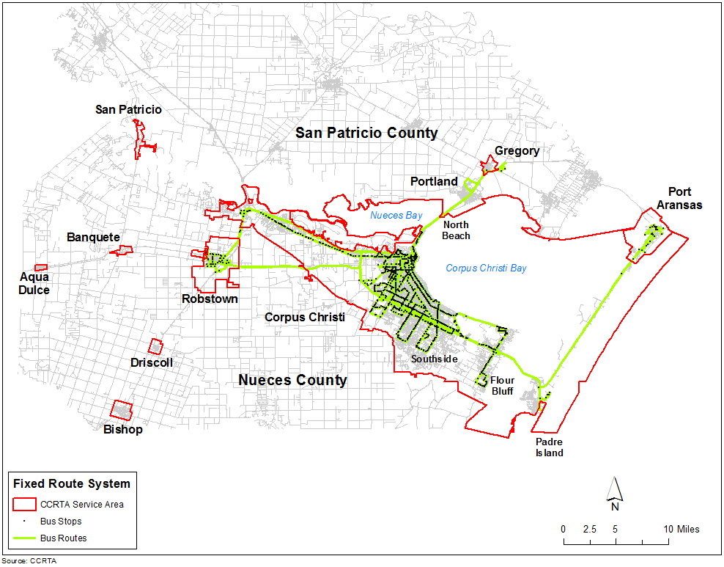

# Application Process

Completed applications (Part I – IV of the 5310 Funding Program Application) should be submitted to the Corpus Christi Regional Transportation Authority (CCRTA).

Applications submitted after the posted deadline **WILL NOT** be considered. All required attachments **MUST** accompany the original application.

Submit original application with six (6) copies to the Corpus Christi Regional Transportation Authority located at 602 N. Staples Street, 3rd Floor, Corpus Christi, Texas 78401 no later than **3:00 p.m.** on deadline date of **May 25, 2018.**

Applicant may be asked to be present at a meeting to answer any questions regarding the submitted application. Applicants will be notified prior to meeting of the time and location.

# Application Submission

The 5310 Call for Projects and project selection will adhere to the following schedule:

**2018 Application and Project Selection Schedule**

4/17/2018: Application available for Section 5310 funds ([www.ccrta.org](http://www.ccrta.org))

5/04/2018: Grant Application Workshop (3rd Floor – Multi-Purpose Conference Room)

5/25/2018: Last Day to submit COMPLETED application for Section 5310 funds

7/25/2018: Completion of the evaluation of applications

8/01/2018: CCRTA Board approval for Section 5310 Projects

8/24/2018: Award Notification sent via letter to Awardees

9/17/2018: Mandatory Sub-Recipient Orientation

9/24/2018: Sub-Recipient Agreements signed and executed

After a project application has been selected for funding, CCRTA will coordinate with the Sub-Recipient to submit the necessary FTA documentation

# Contact Information

Christina A. Perez, DBE/EEO Compliance Officer

CCRTA

602 N. Staples Street, 3rd Fl.

Corpus Christi, TX 78401

(361) 903-3461

[cperez@ccrta.org](mailto:cperez@ccrta.org)

# Project Evaluation Criteria

FTA allows but does not require the use of selection criteria for awarding 5310 funding. Selection criteria was developed to guide application review and project selection. Projects funded under the Section 5310 programs must be selected competitively. An evaluation criterion with an award of a maximum of 100 points is developed to score and rate project applications. The criteria align closely with ‘Part II – Project Narrative’ section of the application.

1. **Statement of Needs (20 points)**

Project applications should clearly state the need for the project and demonstrate how the project is consistent with the objectives of the grant program. The project application should indicate how the project will enhance transportation for the urbanized area’s elderly and disabled populations, as well as, the connection between the project and the Coordinated Plan should be clearly described in the application.

1. **Project Planning and Implementation (20 points)**

For all projects, applicants must provide a well-defined service operations plan and/or capital procurement plan, and describe the implementation steps and timelines for carrying out the plan. The applicant’s plan should include coordination, eligibility determination, marketing and service delivery details.

1. **Project Budget and grants Management (15 points)**

Applicants must submit a completed project budget, indicating anticipated project expenditures and revenues, including documentation of matching funds. The application should address long-term efforts and identify potential funding sources for sustaining the service beyond the grant period.

1. **Program Effectiveness and Evaluation (20 points)**

The project will be scored based on the applicant’s identification of clear, measurable outcome-based performance measures, including customer satisfaction, to track the effectiveness of the service. The applicant should monitor and evaluate the service throughout the period of performance.

1. **Organizational Preparedness and Technical Capacity (25 points)**

Projects should be a good fit in the applicant’s organization. The applicant must demonstrate that it has staff with the technical experience to manage or operate a transportation service, such as correct levels of insurance for operations. In addition, the applicant must show that they are prepared to monitor and provide safe services.

# Scoring Criteria

|  |  |
| --- | --- |
| **PROJECT EVALUATION CRITERIA** | **POSSIBLE POINTS** |
| **Project Needs** | **20** |
| Is the project consistent with the 5310 grant program’s objectives? | 0 or 5 |
| To what degree will the project increase or enhance the availability of transportation for the Corpus Christi Urbanized Area’s elderly and disabled populations? | 0 - 5 |
| Does the project address a need identified in the Coordinated Plan? | 0 or 5 |
| Does the project provide a service that otherwise would not be available? | 0 or 5 |
| **Project Planning and Implementation** | **20** |
| Does the project include coordination and/or partnerships with transportation providers or other relevant stakeholders? | 0 or 5 |
| Is the project timeline realistic? | 0 or 5 |
| To what extent does the applicant include plans to market to the target group and promote public awareness of their project? | 0 - 5 |
| Is there evidence the applicant has done all the necessary planning and is ready to begin the project upon being funded? | 0 - 5 |
| **Project Budget** | **15** |
| Were all the necessary budgets completed and submitted? | 0 - 5 |
| Are the certified local match sources for the project also listed in the budget as matching funds? | 0 - 5 |
| How does the agency propose to continue commitment to the life of the project beyond the availability of the requested grant resources? | 0 - 5 |
| **Program Effectiveness and Evaluation** | **20** |
| Did the applicant mention collecting data and/or documenting the delivery and utilization of services? | 0 or 10 |
| Does the applicant propose monitoring measurable indicators of success? | 0 or 10 |
| **Organizational Preparedness** | **25** |
| How closely does the proposed project align with the organization’s mission and objectives? | 0 - 5 |
| How experienced is the applicant staff in managing transportation projects and/or operating passenger transportation? | 0 - 5 |
| How experienced is the agency with financial responsibilities such as, quarterly reporting, annual audits, and/or other forms of financial reporting? | 0 - 10 |
| Does the applicant propose training, vehicle maintenance, inspection or monitoring to manage risk and to provide safe services? | 0 - 5 |
| **Total Score** | **0 - 100** |